**IaaS vs PaaS vs SaaS**

**SaaS (Software as a Service)**

Software as a Service, or SaaS, is the simplest and most user-friendly cloud service model. Instead of buying software, installing it on individual devices, and keeping it updated, SaaS lets you access complete software applications directly through the internet. Everything is hosted in the cloud, and the provider takes care of installation, updates, security, and maintenance.

To put it simply, imagine you have no coding knowledge at all. You still want an application—something that includes the front end, the back end, and all the behind-the-scenes connections. With SaaS, you don’t have to build it yourself. You just use a ready-made solution provided by a third party.

**Real-World Examples:**  
Think of Salesforce for managing customer relationships, Microsoft 365 for productivity tools like Word and Excel, or Zoom for video meetings. All of these are SaaS products—you don’t have to install complex systems or handle maintenance. You simply log in and start using them.

**Key Characteristics of SaaS:**

* Applications are fully developed and ready to use. The provider takes care of updates, bug fixes, and security.
* You usually access SaaS products through a web browser or a mobile app, paying for them via subscription.
* They’re designed for convenience, requiring little to no technical expertise. This makes them especially attractive to non-technical users and businesses that don’t have in-house IT expertise.

**Popular SaaS Providers:**

* Salesforce
* Google Workspace
* Microsoft 365
* Zoom
* Slack

**When to Use SaaS:**  
SaaS works best when you want software that is immediately usable without any setup hassle. Businesses often choose SaaS for communication, collaboration, or data management tools. It is especially valuable for teams that need reliability, accessibility, and ease of use without investing in technical resources.

**PaaS (Platform as a Service)**

Platform as a Service, or PaaS, sits in the middle of the cloud service spectrum. It gives you a ready-to-use environment for developing, running, and managing applications, while freeing you from the burden of maintaining servers, operating systems, or networking infrastructure.

In simple terms, imagine you already know coding languages like .NET or PHP, and you’re capable of building databases. You don’t want to waste time managing physical servers or operating systems, but you do want a space to build your applications. PaaS provides that space. It equips you with the frameworks, libraries, and tools you need, so you can just focus on writing code and creating your application.

**Real-World Example:**  
A software company developing a new SaaS product could use Google App Engine or AWS Elastic Beanstalk to deploy their application. This way, they can skip the hassle of configuring servers, storage, or networking, and go straight to coding and testing their product.

**Key Characteristics of PaaS:**

* It provides a full toolkit for developers to build, deploy, and manage applications.
* It comes with pre-built tools, libraries, and development environments, which accelerate the development process.
* Developers only manage the applications and data, while the provider takes care of the underlying infrastructure.
* It makes collaboration easier since multiple developers can work together on the same platform.

**Popular PaaS Providers:**

* AWS Lambda
* Google App Engine
* Google Cloud Platform
* IBM Cloud

**When to Use PaaS:**  
PaaS is the right choice for developers building applications—whether web-based or mobile—that need backend services like databases, authentication systems, or messaging features. It allows teams to concentrate on development rather than spending time managing servers or worrying about scaling infrastructure.

**IaaS (Infrastructure as a Service)**

Infrastructure as a Service, or IaaS, provides businesses with virtualized computing resources over the internet. Instead of purchasing physical servers, networking equipment, or storage systems, you rent them from a provider on a pay-as-you-go basis. This gives you access to powerful computing infrastructure without the need to buy and maintain hardware yourself.

In simpler terms, let’s say you’ve already built an entire application and platform using your own coding knowledge. Now, you need somewhere to host it. You need storage, networking, and servers to make your app run smoothly for users. That’s exactly what IaaS gives you: the infrastructure foundation on which your application operates.

**Real-World Example:**  
Imagine a tech startup that suddenly gains a large user base. They need more server capacity quickly, but buying and setting up physical hardware would take too much time and money. By using an IaaS provider like AWS or Microsoft Azure, they can instantly scale up their server resources to meet demand, then scale back down when traffic decreases.

**Key Characteristics of IaaS:**

* It’s like renting virtual machines and storage in the cloud, instead of owning hardware.
* You have full control over the operating system, applications, and development frameworks.
* Scaling resources up or down is straightforward, depending on your business needs.

**Popular IaaS Providers:**

* Amazon Web Services (AWS)
* Microsoft Azure
* Google Compute Engine
* DigitalOcean

**When to Use IaaS:**  
IaaS is best for businesses that want maximum flexibility and control over their infrastructure. It’s often used by IT teams, network architects, and organizations with custom infrastructure requirements. Whether you’re hosting applications, managing data, or running development environments, IaaS gives you the raw building blocks to do so.

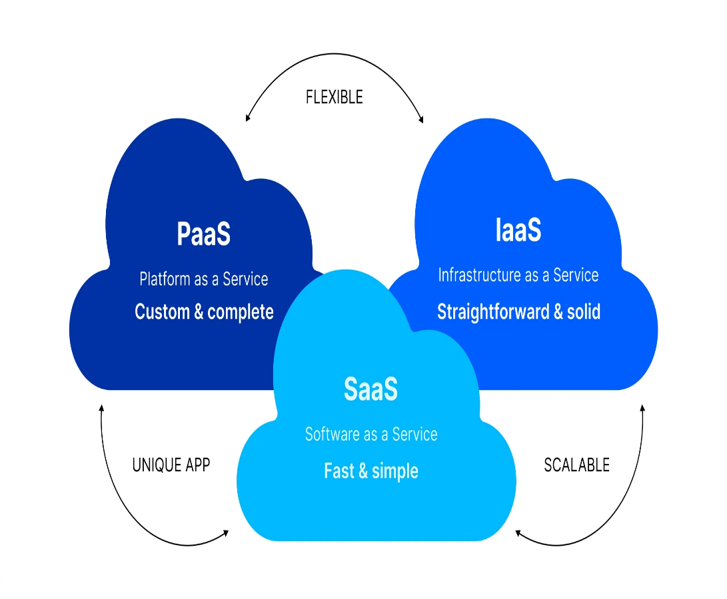

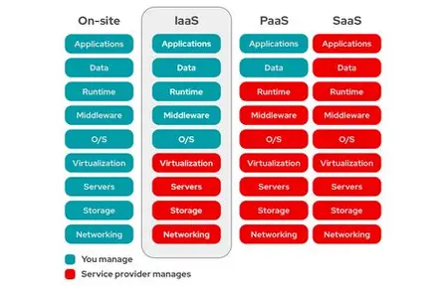

**Conclusion**

In summary, **IaaS, PaaS, and SaaS** represent three different levels of cloud services.

* **IaaS** provides the raw infrastructure—servers, storage, and networking—that businesses can rent and customize as they like.
* **PaaS** offers a ready-made platform for developers to build, run, and manage applications without dealing with the complexity of infrastructure.
* **SaaS** delivers fully developed applications that end users can access directly through the internet, requiring no technical expertise.

Think of it as layers: **IaaS is the foundation, PaaS is the toolkit, and SaaS is the finished product.**

